Netflix clone

1. setup :
2. Git clone –single-branch -b react mini <https://github.com/safak/youtube.git> .
3. npm install yarn -g (optional , if you use npm move on )
4. yarn (or npm install )
5. yarn start (npm start )

2) Change font-style :

1. [Roboto - Google Fonts](https://fonts.google.com/specimen/Roboto)
2. Check your fonts , the copy the link and past it inside index.html :

 <link *rel*="preconnect" *href*="https://fonts.googleapis.com">

<link *rel*="preconnect" *href*="https://fonts.gstatic.com" *crossorigin*>

<link *href*="https://fonts.googleapis.com/css2?family=Roboto:ital,wght@0,300;0,400;0,500;0,900;1,700&display=swap" *rel*="stylesheet">

1. COPY -> CSS rules to specify families -> past it into <styles></styles> inside index.html

      font-family: 'Roboto', sans-serif;

3) install sass :

1. Yarn add sass
2. Make new file app.scss into src and new folder and new file Home.jsx
3. 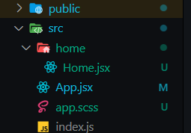
4. App.jsx :

import './app.scss';

import Home from "./home/Home";

*const* App = () *=>* {

  return <Home />;

};

export default App;

5)work with sass :

At app.scss make our main color ,

:Root is accessible from any file

*:root*{

    --main-color: #0b0b0b

}

Make new file home.scss and :

*.home*{

    background-color: var(--main-color);

}

Import it into home.jsx and give a div a className home .

6) [Material icons - MUI](https://mui.com/components/material-icons/) :

1) yarn add @material-ui/icons @material-ui/core

7) NETFLIX FIXED NAVBAR :

1)create folder components containing folder Navbar including Navbar.jsx and Navbar.scss

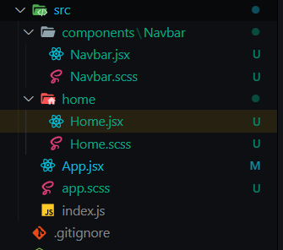

1. Navbar.jsx :

import { Notifications, Search } from "@material-ui/icons";

import "./Navbar.scss";

*function* Navbar() {

    return (

        <div *className*="navbar">

          <div *className*="container">

              <div *className*="left">

                  <img *src*="https://upload.wikimedia.org/wikipedia/commons/thumb/0/08/Netflix_2015_logo.svg/2560px-Netflix_2015_logo.svg.png" *alt*="" />

                  <span>Home page</span>

                  <span>Series</span>

                  <span>Movies</span>

                  <span>New and popular</span>

                  <span>My List</span>

              </div>

              <div *className*="right">

                <Search />

                <span>KID</span>

                <Notifications />

              </div>

          </div>

        </div>

    );

}

export default Navbar;

1. Home.jsx :

import "./Home.scss";

import React from 'react';

import Navbar from "../components/Navbar/Navbar";

*function* Home() {

    return (

        <div *className*="home">

            <Navbar />

        </div>

    );

}

export default Home;

1. Navbar.scss :

*.navbar*{

    color : white ;

    font-size: 14*px* ;

*.container*{

        padding: 0*px* 50*px* ;

        display: flex;

        align-items: center;

        justify-content: space-between;

        img{

            height: 30*px*;

        }

    }

}



1. Add img and arrowdrop down at right container :

   <img

*src*="https://images.pexels.com/photos/6899260/pexels-photo-6899260.jpeg?auto=compress&cs=tinysrgb&dpr=2&w=500"

*alt*=""

          />

          <ArrowDropDown />

1. Navbar.scss :

*.navbar*{

    color : white ;

    font-size: 14*px* ;

*.container*{

        padding: 0*px* 50*px* ;

        display: flex;

        align-items: center;

        justify-content: space-between;

        height: 70*px*;

*.left*{

            display: flex;

            align-items: center;

            img{

                height: 30*px*;

                margin-right: 40*px*;

            }

            span{

                margin-right : 20*px*;

                cursor: pointer;

            }

        }

*.right*{

            display: flex;

            align-items: center;

            img{

                width: 30*px*;

                height: 30*px*;

                border-radius: 5*px* ;

                object-fit : cover;

                cursor: pointer;

                        }

        }

    }

}



1. Add className to every material_ui component named icon:

                <Search *className*="icon"/>

<Notifications *className*="icon"/>

          <ArrowDropDown *className*="icon" />

1. Add this css code to right side class :

*.right*{

            display: flex;

            align-items: center;

 // -> add this code

*.icon*{

                    margin: 0*px* 15*px* ;

                    cursor: pointer;

                }



1. Make ArrowDropDown inside container named profile and add to it options div

<div *className*="profile">

          <ArrowDropDown *className*="icon" />

           <div *className*="options">

            <span>Settings</span>

            <span>Logout</span>

          </div>

1. Inside navbar.scss , inside .right {} add .profile and work on it normal and hover :

*.profile*{

                        span{

                            padding: 10*px*;

                            cursor: pointer;

                        }

*.options*{

                            display: none;

                            background-color: var(--main-color);

                            border-radius: 5*px* ;

                        }

                        &*:hover*{

*.options*{

                                display: flex;

                                flex-direction: column;

                                position: absolute;

                            }

                        }

                    }

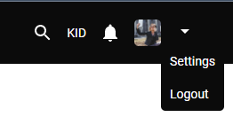

1. Go to Home.jsx and make you component looks like this :

        <div *className*="home">

            <Navbar />

            Lorem ipsum dolor sit amet, consectetur adipiscing elit, sed do eiusmod tempor incididunt ut labore et dolore magna aliqua. Ut enim ad minim veniam, quis nostrud exercitation ullamco laboris nisi ut aliquip ex ea commodo

.

.

. // repeat code

.

.

            Lorem ipsum dolor sit amet, consectetur adipiscing elit, sed do

</div>

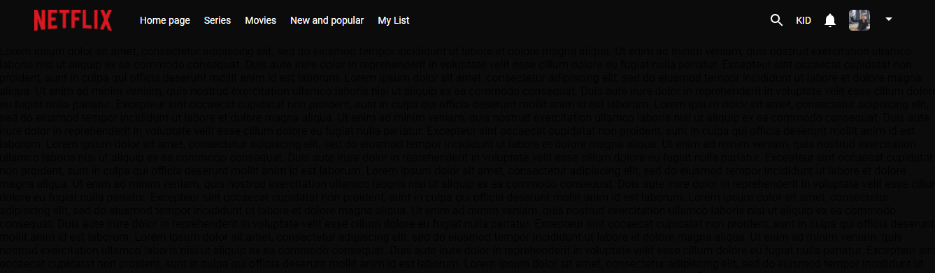

1. Fixed to navbar :

  position: fixed;

    top:0;

    width: 100*%*;

z-index: 999;

add this code above .container{}…

1. Add img under <Navbar / > in Home.jsx :

  <div *className*="home">

            <Navbar />

            <img

*width*="100%"

*src*="casa.jpg"

*alt*=""

          />

            Lorem ipsum dolor sit amet, consectetur adipiscing elit

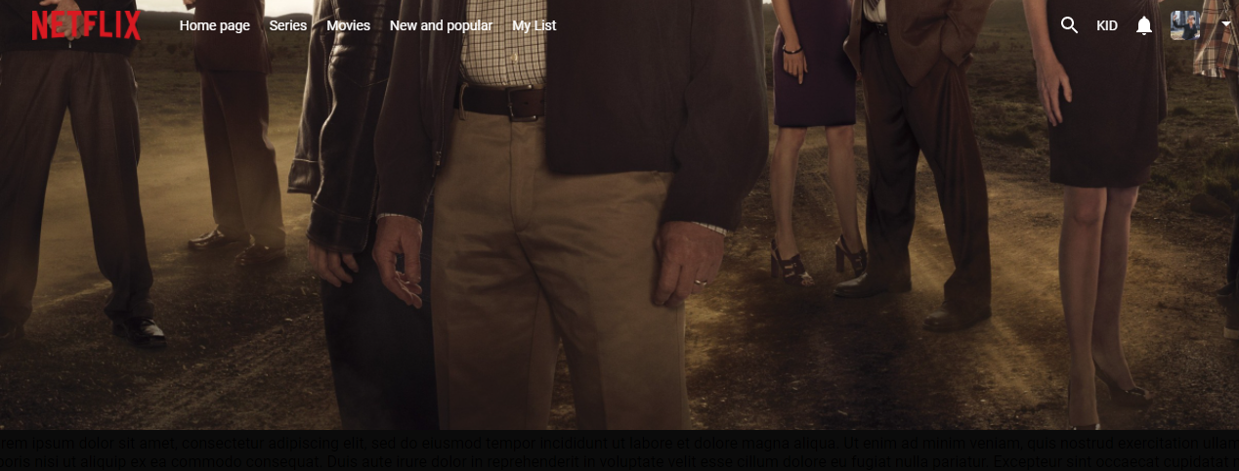

Fix navbar color background :

    background: 1inear-gradient(to top, transparent 0*%*, rgb(0, 0, 0, 0.3), 50*%*);

at Navbar.jsx :

*const* [isScrolled, setIsScrolled] = useState(false);

*window*.onscroll = () *=>* {

  setIsScrolled(*window*.*pageYOffset* === 0 ? false : true);

  return () *=>* (*window*.*onscroll* = null);

};

*console*.log(isScrolled);

Scroll and test :

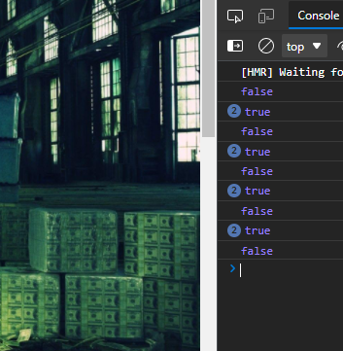

And make div navbar like that :

        <div *className*={isScrolled ? "navbar scrolled" : "navbar"}>

And add :

    &*.scrolled*{

        background-color: var(--main-color);

    }

Inside navbar{..}

7) NETFLIX FEATURED MOVIE :

Create featured folder inside components including Featured.jsx , Featured.scss :

1)Featured.jsx :

import { InfoOutlined, PlayArrow } from "@material-ui/icons";

import "./Featured.scss"

*function* Featured(props) {

*function* Featured({type}) {

    return (

        <div *className*="featured">

        {type && (

          <div *className*="category">

            <span>{type === "movie" ? "Movies" : "Series"}</span>

            <select *name*="genre" *id*="genre">

              <option>Genre</option>

              <option *value*="adventure">Adventure</option>

              <option *value*="comedy">Comedy</option>

              <option *value*="crime">Crime</option>

              <option *value*="fantasy">Fantasy</option>

              <option *value*="historical">Historical</option>

              <option *value*="horror">Horror</option>

              <option *value*="romance">Romance</option>

              <option *value*="sci-fi">Sci-fi</option>

              <option *value*="thriller">Thriller</option>

              <option *value*="western">Western</option>

              <option *value*="animation">Animation</option>

              <option *value*="drama">Drama</option>

              <option *value*="documentary">Documentary</option>

            </select>

          </div>

        )}

        <img

*src*="casa.jpg"

*alt*=""

        />

        <div *className*="info">

          <img

*src*="https://www.pngplay.com/wp-content/uploads/6/Breaking-Bad-Logo-PNG-HD-Quality.png"

*alt*=""

          />

          <span *className*="desc">

            Lorem ipsum dolor sit amet consectetur adipisicing elit. Vitae

            adipisci repellendus eum quasi illo, velit numquam, maxime tempora

            sint deleniti, aliquid qui? Facilis, adipisci! Ratione hic repudiandae

            temporibus eum earum?

          </span>

          <div *className*="buttons">

            <button *className*="play">

              <PlayArrow />

              <span>Play</span>

            </button>

            <button *className*="more">

              <InfoOutlined />

              <span>Info</span>

            </button>

          </div>

        </div>

      </div>

    );

}

export default Featured;

2)Featured.scss:

*.featured* {

    height: 90*vh*;

    position: relative;

*.category* {

      position: absolute;

      top: 80*px*;

      left: 50*px*;

      font-size: 30*px*;

      font-weight: 500;

      color: white;

      display: flex;

      align-items: center;

      select {

        cursor: pointer;

        background-color: var(--main-color);

        border: 1*px* solid white;

        color: white;

        margin-left: 20*px*;

        padding: 5*px*;

        font-size:  medium;

      }

    }

    img {

      width: 100*%*;

      height: 100*%*;

      object-fit: cover;

    }

*.info* {

      width: 35*%*;

      position: absolute;

      left: 50*px*;

      bottom: 100*px*;

      color: white;

      display: flex;

      flex-direction: column;

      img {

        width: 400*px*;

      }

*.desc* {

        margin: 20*px* 0*px*;

      }

*.buttons* {

        display: flex;

        button {

          padding: 10*px* 20*px*;

          border: none;

          border-radius: 5*px*;

          display: flex;

          align-items: center;

          justify-content: center;

          font-size: 18*px*;

          font-weight: 500;

          margin-right: 10*px*;

          cursor: pointer;

          &*.play* {

            background-color: white;

            color: var(--main-color);

          }

          &*.more* {

            background-color: gray;

            color: white;

          }

          span {

            margin-left: 5*px*;

          }

        }

      }

    }

  }

Home.jsx :

*function* Home() {

    return (

        <div *className*="home">

            <Navbar />

           <Featured *type*={"movie"} />

        </div>

    );

}

7) NETFLIX SLIDER :

[Sponsor Slider (Bootstrap 3.3.7) (codepen.io)](https://codepen.io/cmoen89/pen/ymXaaN)

Create folder and files :

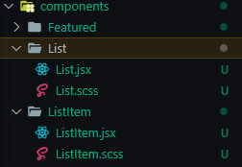

1)List.jsx :

import { ArrowBackIosOutlined, ArrowForwardIosOutlined } from "@material-ui/icons";

import ListItem from "../ListItem/ListItem";

import "./List.scss";

*function* List(props) {

  return (

    <div *className*="List">

      <span *className*="ListTitle">Continue to watch</span>

      <div *className*="wrapper">

        <ArrowBackIosOutlined />

        <div *className*="container">

            <ListItem />

        </div>

        <ArrowForwardIosOutlined />

      </div>

    </div>

  );

}

export default List;

2) List.scss :

*.List* {

    width: 100*%*;

    margin-top: 10*px*;

*.ListTitle* {

      color: white;

      font-size: 20*px*;

      font-weight: 500;

      margin-left: 50*px*;

    }

*.wrapper* {

      position: relative;

*.container* {

        margin-left: 50*px*;

        display: flex;

        margin-top: 10*px*;

        width: max-content;

        transform: translateX(0*px*);

        transition: all 1*s* ease;

      }

    }

  }

3)ListItem.jsx :.

import './ListItem.scss';

*function* ListItem(props) {

    return (

        <div *className*='ListItem'>

            Liste item

        </div>

    );

}

export default ListItem;

4)ListItem.scss :

*.ListItem* {

    width: 225*px*;

    height: 120*px*;

    background-color: var(--main-color);

    margin-right: 5*px*;

    overflow: hidden;

    cursor: pointer;

    color: white;

    &*:hover* {

      width: 325*px*;

      height: 300*px*;

      position: absolute;

      top: -150*px*;

*// If we use -webkit-box-shadow the old versions of browsers support it.*

      -webkit-box-shadow: 0*px* 0*px* 15*px* 0*px* rgba(255, 255, 255, 0.07);

      box-shadow: 0*px* 0*px* 15*px* 0*px* rgba(255, 255, 255, 0.07);

      border-radius: 5*px*;

    }

  }

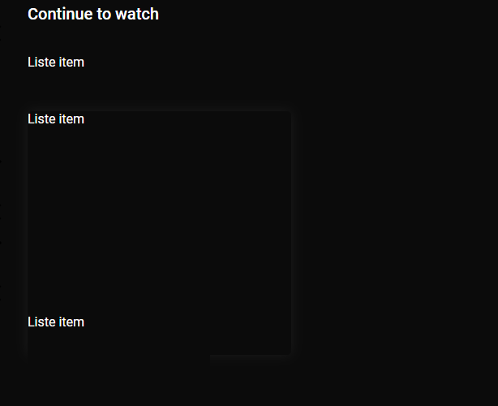

Add classes to arrows:

// List.jsx :

<ArrowBackIosOutlined *className*="sliderArrow left" />

  <ArrowForwardIosOutlined *className*="sliderArrow right" />

Inside list.scss -> wrapper { } : add this

*.sliderArrow* {

        width: 50*px*;

        height: 100*%*;

        background-color: rgb(22, 22, 22, 0.5);

        color: white;

        position: absolute;

        z-index: 99;

        top: 0;

        bottom: 0;

        margin: auto;

        cursor: pointer;

        &*.left* {

          left: 0;

        }

        &*.right* {

          right: 0;

        }

      }

7) NETFLIX FOOTER :

Footer.scss :

  footer {

    background-color: var(--main-color);

    color: #a7a7a7;

    font-size: 16*px*;

    height: 250*px*;

    margin-top : 1*%*;

    padding-top: 2*%*;

    border-top: 2*px* solid rgb(56, 50, 50);

  }

  footer * {

    font-family: "Poppins", sans-serif;

    box-sizing: border-box;

    border: none;

    outline: none;

  }

*.row.primary* {

    display: grid;

    grid-template-columns: 2*fr* 1*fr* 1*fr* 2*fr*;

    align-items: stretch;

  }

*.column* {

    width: 100*%*;

    display: flex;

    flex-direction: column;

    padding: 0 2*em*;

    min-height: 15*em*;

  }

  h3 {

    width: 100*%*;

    text-align: left;

    color: white;

    font-size: 1.4*em*;

    white-space: nowrap;

  }

  ul {

    list-style: none;

    display: flex;

    flex-direction: column;

    padding: 0;

    margin: 0;

    padding-top: 8*px*;

  }

  ul li a {

    color: #a7a7a7;

    text-decoration: none;

  }

  ul li a*:hover* {

    color: #ed2a2a;

  }

*.about* p {

    text-align: justify;

    line-height: 2;

    margin: 0;

  }

  input,

  button {

    font-size: 1*em*;

    padding: 1*em*;

    width: 100*%*;

    border-radius: 5*px*;

    margin-bottom: 5*px*;

  }

  button {

    background-color: #eb0000;

    color: #ffffff;

  }

Footer.jsx :

import './Footer.scss';

*const* Footer = () *=>* {

    return (

<footer>

<div *class*="row primary">

  <div *class*="column about">

  <h3>Netflix@2022</h3>

   <p>

      Lorem ipsum dolor sit amet consectetur adipisicing elit. Vitae,

      voluptatem corporis error non,

  </p>

</div>

<div *class*="column links">

<h3>Support</h3>

 <ul>

  <li>

   <a *href*="#faq">F.A.Q</a>

  </li>

  <li>

   <a *href*="#cookies-policy">Cookies Policy</a>

  </li>

  <li>

   <a *href*="#terms-of-services">Terms Of Service</a>

  </li>

  <li>

   <a *href*="#support">Support</a>

  </li>

 </ul>

</div>

<div *class*="column links">

  <h3>Contact</h3>

   <ul>

    <li>

     <a *href*="#faq">F.A.Q</a>

    </li>

    <li>

     <a *href*="#cookies-policy">Cookies Policy</a>

    </li>

    <li>

    <a *href*="#terms-of-services">Terms Of Service</a>

    </li>

    <li>

    <a *href*="#support">Support</a>

    </li>

  </ul>

</div>

<div *class*="column subscribe">

 <h3>Newsletter</h3>

  <div>

   <input *type*="email" *placeholder*="Netflix@gmail.com" />

   <button>Service code</button>

  </div>

  <p>Copyright &copy; 2021 Foolish Developer</p>

</div>

</div>

</footer>

     );

}

export default Footer;